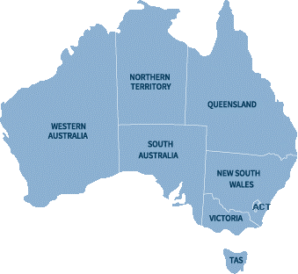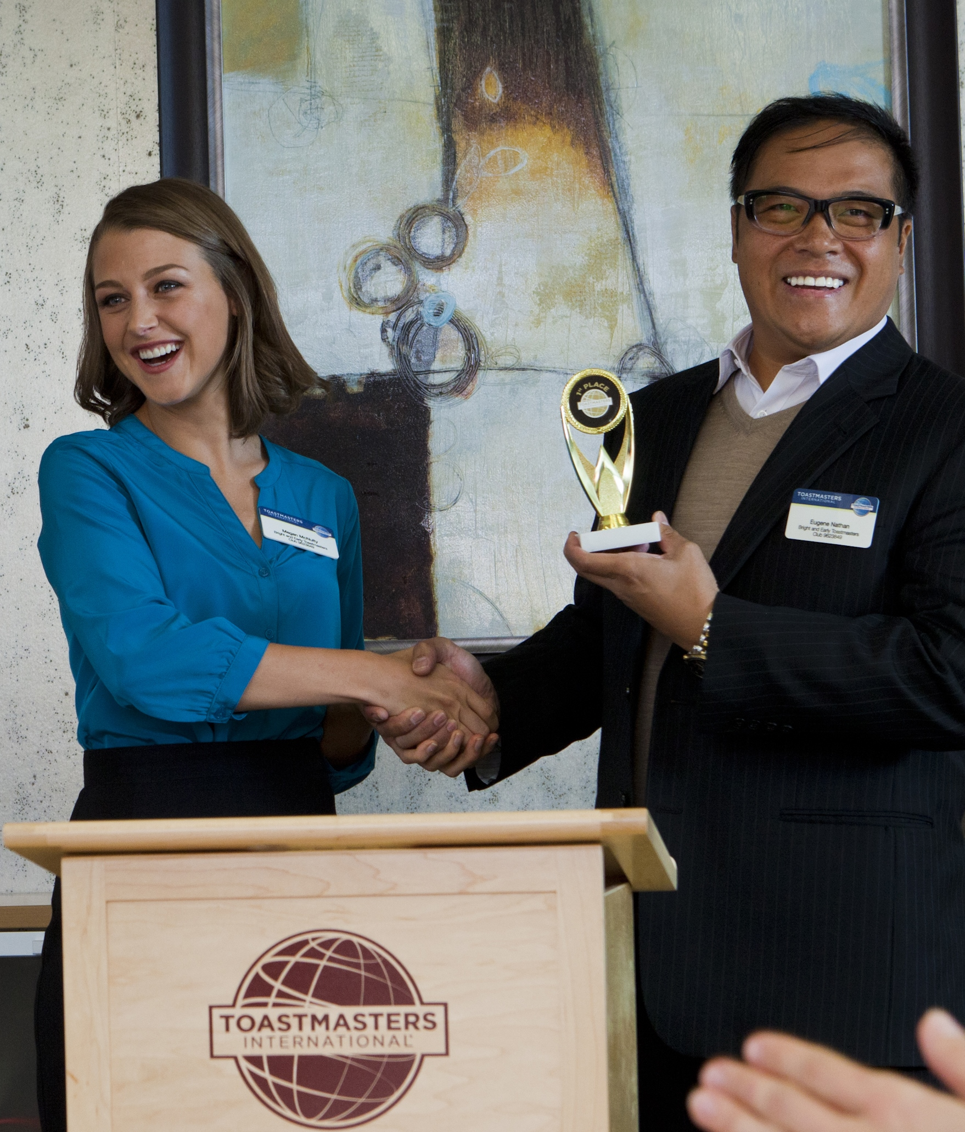

Contact Information:

**TOASTMASTERS**

*Through Toastmasters, I have acquired skills as a leader and trainer - both of which are invaluable in my career.*

***Jan Vecchio***

*I learnt how to lead and better communicate through powerful words and encouraging feedback.*

**Elizabeth Van Phao**

*As a Manager, I was increasingly asked to speak to large audiences, but I would try to avoid it. After joining Toastmasters, I now find it thrilling.*

**Colin Steber**

*Through Toastmasters I was able to control my stutter.  The positive and supportive environment allowed me to practice and work on fluency in speaking.*

**Suben Subenthiran**

*Joining Toastmasters was a wonderful way for me to make friends when I moved to the country.*

**Alison Cleaver**

With over 800 clubs all around Australia, there’s bound to be a club near you.

# This Is What Our

# Members Are Saying...

# Find A Club Near You

“Simply the best   
way to develop confidence,   
public speaking and leadership skills”

www.toastmasters.org.au

# What’s In It For You?

# How Does

# Toastmasters Work?

# Toastmasters Offers 10 Diverse Learning Paths.

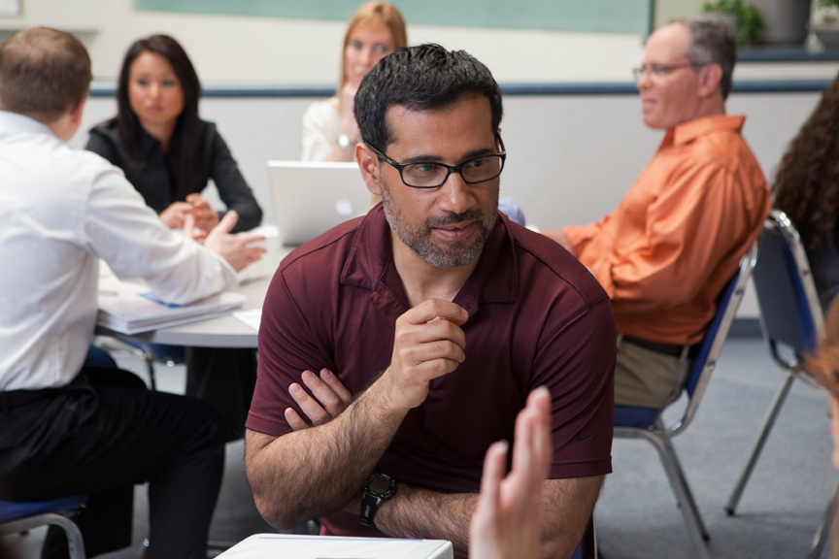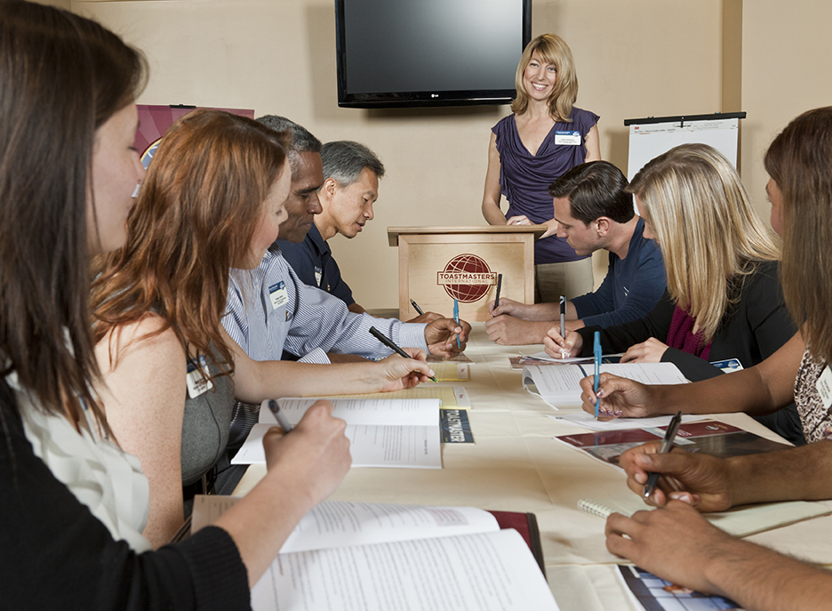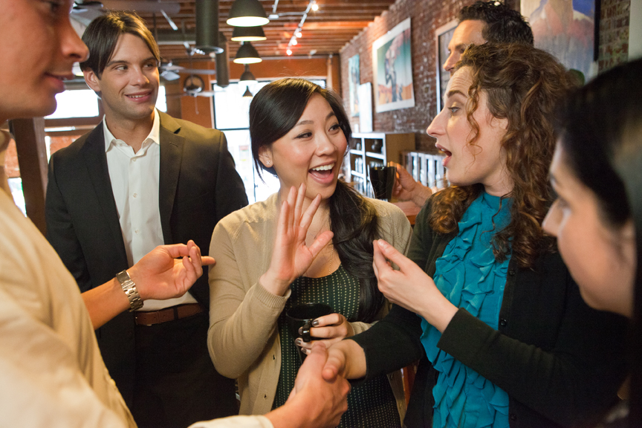

## What happens at a club meeting?

Members prepare presentations which could be 2 minutes or 7 minutes or maybe more depending on the project requirements. In addition, members practice impromptu speaking in a fun session called Table topics.

## Our Secret …

Members receive carefully crafted feedback, highlighting what they are doing well and how they can improve. It is with positive feedback that members can build confidence and develop as speakers.

Learn to be more comfortable socially

Get excellent ongoing training

www.toastmasters.org.au

We meet in clubs of about   
10-30 members gathering usually once a fortnight.

Motivational Strategies

Persuasive Influence

Presentation Mastery

Strategic Relationships

Team Collaboration

Visionary Communication

Leadership Development

Innovative Planning

Effective Coaching

Dynamic Leadership

Develop your career

Make new friends and colleagues